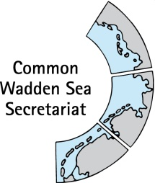
MEETING DOCUMENT
Ad hoc Working Group SWIMWAY (WG-SWIMWAY 20-1)
8 April 2020
Virtual meeting

Agenda Item: 4. SWIMWAY projects
Subject: SWIMWAY project inventory
Document No.: WG-SWIMWAY 20-1/4
Date: 26 March 20
Submitted by: CWSS

At their meeting in January 2019 in Bremen, Germany the Swimway group (now: WG-SWIMWAY) discussed a compilation of projects of relevance for SWIMWAY. Meeting participants are invited to hand in updates of projects run under the SWIMWAY action programme to the CWSS until 6 April 2020.
This document contains an updated inventory of SWIMWAY projects in the trilateral Wadden Sea Area.

Proposal: The group is invited to note the document.

