**TASK GROUP**

**World Heritage**

**TG-WH 37**

**12 - 13 July 2022**

**Virtual Meeting**

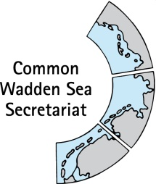

_________________________________________________________________________

**Agenda Item:** 3

**Subject:** Announcements CWSS

**Document No.** TG-WH 37/3/1

**Date:** 27 June 2022

**Submitted by:** CWSS

_________________________________________________________________________

Attached are announcements from the CWSS.

**Proposal**

The meeting is proposed to note the announcements.

**Announcements CWSS**

# East Atlantic Flyway Youth Forum, 9 – 10 July 2022

The EAFYF 2021 has shown a lot of commitment by young people along the East Atlantic Flyway - they are ready to take action. While many of them volunteer their time for research and monitoring activities, or organising campaigns to raise awareness for flyway issues, it is clear that funds are urgently needed to ensure activities and outcomes are sustainable.

The aim of the East Atlantic Flyway Youth Forum 2022 is to support young people in raising funds for conservation initiatives by increasing their capacity to successfully write grant proposals. Therefore, an online fundraising workshop is planned for up to 30 participants on 9th - 10th July 2022.

# eDNA project in Marine World Heritage Sites

As announced earlier to TG-WH (March 2022), the World Heritage Centre has launched an “environmental DNA” project in late 2021 (<https://ednaexpeditions.org/>). For the next two years, the eDNA project will engage local citizens and scientists to help measure sites’ vulnerability to climate change through environmental DNA sampling expeditions (with focus on fish species). Data will be stored in the global open science database OBIS at the Intergovernmental Oceanographic Commission of UNESCO

The Centre has also approached CWSS for potential cooperation partners in the Wadden Sea World Heritage and to join the pilot phase (five marine sites) in 2022. An online exchange meeting was organized on 19 May 2022 to get further information on the project including timeline for sampling. The trilateral contact persons in the countries have also been involved (22 April) and it is planned to start sampling in September 2022. The pilot sampling campaigns (engagement of youth, schools, citizen scientists, and/or local communities) will be organized in the next months, in close collaboration with local authorities responsible for the management of marine World Heritage sites and with the assistance of local (eDNA) scientists. In total 20 samples will be taken (5 samples in Denmark, Schleswig-Holsten, Niedersachsen and the Netherlands).

# Third East Atlantic Flyway assessment report shows flyway trends of migratory waterbird populations

Every three years, the Wadden Sea Flyway Initiative, in collaboration with BirdLife International, Wetlands International and numerous other local and international partners, coordinates a flyway-wide simultaneous bird count. In January 2020, over 13,000 people counted migratory waterbirds at more than 1,000 sites in 36 countries along the East Atlantic Flyway. The key findings have now been published in an [extensive assessment report](https://www.waddensea-worldheritage.org/node/1674).

The report gives an overview of the current situations and threats to the birds. Thanks to the simultaneous count, trends in numbers for 83 flyway populations have been identified: 30% of the surveyed populations are decreasing, while 50% are increasing and 16% are stable. The now third flyway-wide count also showcases that the declines in long-distance migratory waders, such as the Bar-tailed godwit, continue.

The researchers further state that negative impacts of climate change increasingly threaten birds and their habitats along the flyway. In Europe, sea level rise is already named among the top three pressures. In Africa the effects of climate change are equally severe, but other threats, such as fishing and forest logging, are reported even more frequently.

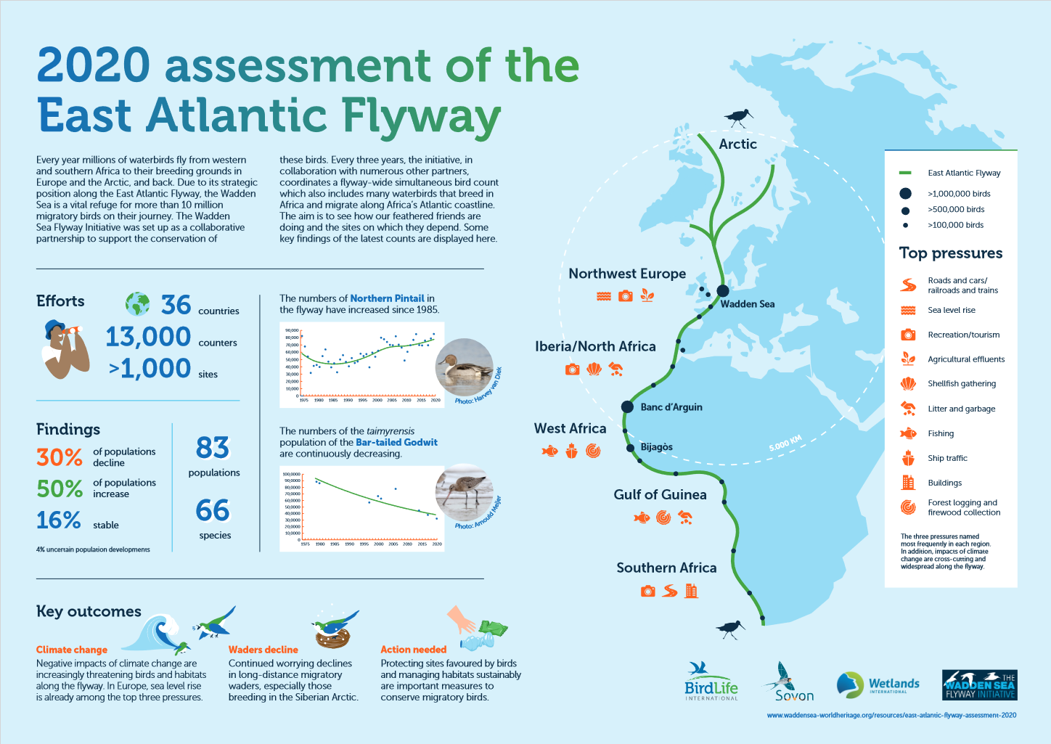

Figure: New infographic showing the results of the flyway-wide simultaneous bird count

Download at: <https://www.waddensea-worldheritage.org/sites/default/files/2022_East%20Atlantic%20Flyway%20Assessment%20Poster_0.pdf>

# Transnational visitor survey highlights the importance of protected nature to Wadden Sea guests

In 2020-2021, a visitor survey covering the entire destination of the Wadden Sea World Heritage in Denmark, Germany and the Netherlands was conducted. Its output shows that over 90 percent of guests know that the Wadden Sea is designated as World Heritage site. Additionally, nature protection and information about nature experience are important aspects to the visitors for their stay. The survey is the first visitor study conducted in the three Wadden Sea states simultaneously, led by the National Park Authority Schleswig-Holstein Wadden Sea/) in the framework of Interreg project “[PROWAD Link](https://northsearegion.eu/prowad-link)”. The survey is a novelty and allows to some extent to compare the results between the different regions.

In the Danish, Dutch and German parts of the Wadden Sea, more than 90 percent of guests knew that the area is inscribed as World Heritage site, proving a high awareness for this status. The status did play a role for the travel decision for more than half of the Danish interviewees and about for 40% of the interviewees in Germany and the Netherlands (see figure 1)

The environmental aspects for the holiday seem to be of high importance: More than 80 percent of the visitors want the nature at the destination to be protected and prefer to experience an intact nature away from large tourist crowds. For more than 70 percent it is moreover important to learn something about the region as well as the nature at their destination. Nature experience trails and Wadden Sea exhibition centers are at the top 3 of nature tourism offers in all three countries. While trips to seal colonies and guided trips to the islands made the list in Denmark and the Netherlands, respectively, almost half of all the guests in the German Wadden Sea destination have a tidal flat tour on their summer bucket list (see figure 2)

The anonymous survey asked guests where they received their information from about the holiday location and the Wadden Sea, and the motives for their travel decision. The answers provide information on what kind of tourist and nature experiences are popular and how they are rated, as well as visitors’ perception of Wadden Sea World Heritage, nature protection, and responsible travel.

The results can be viewed per country in the following chart reports: [Denmark](https://www.waddensea-worldheritage.org/node/1711) | [Germany](https://www.waddensea-worldheritage.org/node/1710) | [Netherlands](https://www.waddensea-worldheritage.org/node/1712). A brochure on the results is in works and will be published in the near future.



Figure 1: World Heritage and travel decision



Figure 2: Interest in nature offers