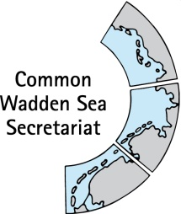
MEETING DOCUMENT
Task Group World Heritage (TG-WH 32)
29 January 2021
Virtual meeting

Agenda Item: 4. Single integrated management plan
Subject: 4-5 Vision, objectives, principles and purpose
Document No.: TG-WH 32/4-5
Date: 21 January 2021
Submitted by: CWSS and subgroup
TH-WH 31 agreed to form a subgroup to formulate the vision and mission of the SIMP to complement the agreed Purpose of the SIMP (Section 1.2 in SIMP version 0.3).
The subgroup proposes to include the Guiding Principle, Vision and objectives of the TWSC and management principles of the WSP as the basis/background of the SIMP under Section 1.1 Background of the draft SIMP document in addition to Section 1.2. Purpose of the SIMP.
This document presents the proposed content organised in the following two points:
- Guiding principle, vision, objectives of TWSC and management principles of WSP – as part of Section 1.1 Background
- Purpose of the SIMP (Section 1.2 in the SIMP document)

Proposal: The meeting is invited to approve this suggestion and content.

- Guiding principle, vision, objectives of TWSC and management principles of WSP – as part of Section 1.1 Background
The TWSC follows overriding and overarching objectives that are framed by the Vision for the Wadden Sea and the Guiding Principle (Joint Declaration on the Protection of the Wadden Sea 1982, reviewed 2010) that are in line with the Outstanding Universal Value of the Wadden Sea World Heritage.
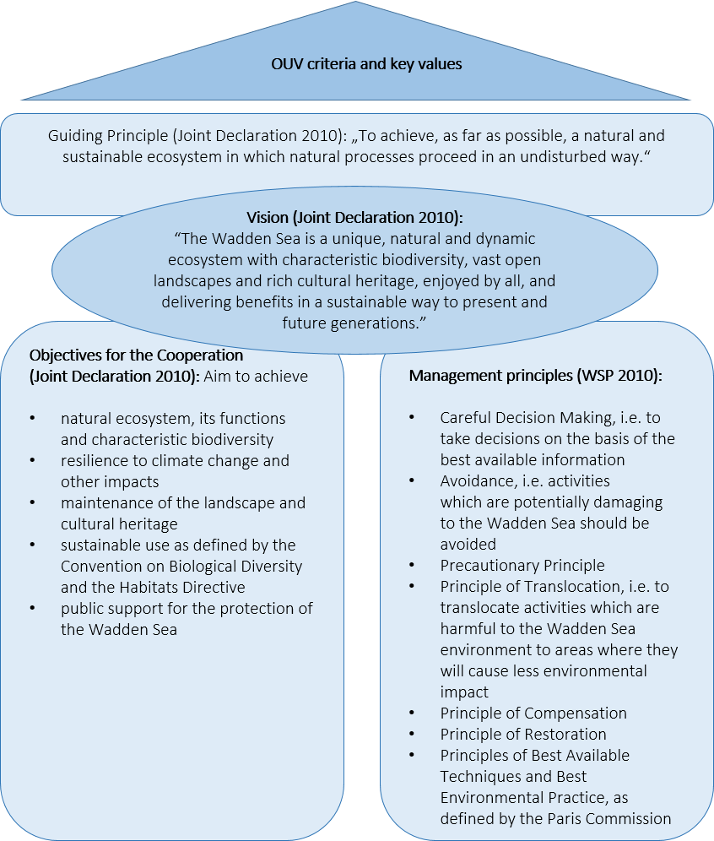

Figure 1. Vision, guiding principle and objectives of the TWSC - as basis/ background for the SIMP.

- Purpose
In light of the wealth and diversity of management systems and instruments that are in place in the Wadden Sea World Heritage (WSWH), the purpose of the single integrated management plan (SIMP), as agreed by the TWSC and stated in Annex 1 of the Leeuwarden Declaration (2018), is to further facilitate the continuous improvement of management coordination for the protection and maintenance of the Outstanding Universal Value by:
- providing a clear overarching description of the management system at the regional, national and trilateral level;
- addressing key topics presenting concrete threats to the Outstanding Universal Value which have been prioritized as pending management tasks;
- present existing joint management activities across the property and showcase gaps which need enhanced joint efforts to maintain the area’s Outstanding Universal Value

