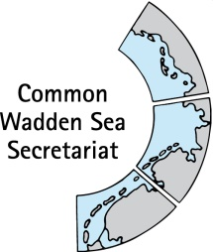
MEETING DOCUMENT
Task Group Management (TG-M 22-2)
5 April 2022
Online meeting

Agenda Item: 2. Summary record
Subject: Draft summary record TG-M 22-2
Document No.: TG-M 22-2/2
Date: 31 March 2022
Submitted by: CWSS

This document contains the summary record of TG-M 22-1 held on 17 January 2022.

Proposal: The group is invited to adopt the document.

Version Log
Issue Date | Version | Author | Change
2022-01-17 | v0.1 | CWSS | First draft of the document
2022-01-21 | v0.1 | chair | Approval
2022-02-01 | v0.1 | MSa | Minor changes
2022-02-04 | v0.1 | MB | Minor changes
2022-02-04 | v0.2 | CWSS | Inclusion to v0.2
Note from CWSS: this version log is for my personal overview and will be omitted in final version.

DRAFT SUMMARY RECORD v0.1
Meeting of the
Task Group Management (TG-M 22-1)
17 January 2022
Online meeting

- Opening of the Meeting and adoption of the Agenda
The meeting was opened by the chair, Henrik Jørgensen at 13:00 on 17 January 2022. He passed apologies from Nina Schröder and Janne Lieven. Maren Bauer attended until 15:15. A list of attendees is at Annex 1.
TG-M adopted the agenda of the meeting (Annex 2).

- Adoption of the draft summary record
Document: TG-M22-1-2_SR21-5
TG-M adopted the draft summary record of TG-M21-5.

- Announcements
Denmark, Germany, Hamburg Netherlands, CWSS
No announcements

Lower Saxony
- Release of concept for conservation measures in Lower Saxon National Park according to EU Habitat Directive (see agenda item 4).

Schleswig-Holstein
- Infomobil (see agenda item 7)

- Habitat management
Margrita Sobottka presented habitat management action sheets, which were recently published by Lower Saxon National Park Authority (Annex 4). https://www.nlwkn.niedersachsen.de/natura2000/ffh_richtlinie_und_ffh_gebiete/die_einzelnen_ffh_gebiete/ffh-gebiet-001-nationalpark-niedersachsisches-wattenmeer-197123.html#sicherung

TG-M thanked Margrita Sobottka and noted the information

- Renewable Energy
Document: TG-M22-1-5-draft_TOR_ad_hoc_cables_pipelines
Margrita Sobottka informed on progress in formation of ad hoc Working Group ‘Cables and Pipelines’ (ad hoc WG-CP). TG-M discussed Draft Terms of Reference for the ad hoc WG. The WG will tackle paragraph 29 of the Leeuwarden Declaration 2o18 “Instruct the Wadden Sea Board to review and monitor the impacts of renewable energy production and energy transportation on the Wadden Sea ecosystem and to consider measures to avoid or mitigate possible negative impacts by looking for best environmental practices also with the aim of developing, for example, related common principles to evaluate the impact of high-voltage power cables in the Wadden Sea Area in close consultation with the responsible bodies and stakeholders”. It will function as living lab for trilateral best practice exchange under the umbrella of the Single Integrated Management Plan.
Karst Jaarsma added that outcomes of the groups work may lead to formulation of text for the Ministerial Conference Declaration which is beyond the scope of the SIMP.
TG-M discussed the content of the submitted document. Floris van Bentum inquired on the formulation “alternative solution” in task two. Margrita Sobottka clarified that this refers to the Habitat Directive in the meaning of alternative routing.
TG-M agreed on the general text of the ToR with an addition to task 2 formulated in italics below. The ten Outstanding Universal Value (OUV) key values may be considered for deliverable 1. Members will be suggested and appointed until 24 January 2022.
Task 2: Exchange on existing information on alternative solution (technical/spatial) and mitigation concepts and best practise at different stages: strategic grid planning, spatial planning, project permission and implementation incl. maintenance.
The group further agreed to inform the WSB meeting in March as part of the TG-M progress report.

- Implementation of the Leeuwarden Declaration and work plan TG-M 2021/22
Document: TG-M22-1-6_LD_workplan (see part 1 in https://waddenseasecretariat-my.sharepoint.com/:w:/g/personal/busch_waddensea-secretariat_org/EZ6ZU8gCBmpDoo2AQNYeXaMBZ8LqCkWRYEXoQdGbCi0Rbw?e=2DUwoF )
The group discussed TG-M activities in 2022 (until the Trilateral Governmental Conference, TGC), by using articles of the Leeuwarden Declaration under responsibility of TG-M. LD and beyond (see Annex 5) and current parts of the Policy Assessment Report (PAR).
Margrita Sobottka requested omitting reference of a letter of intent (Harlingen, NL) in the PAR, LD 33, as this does not contain a commitment to the OUV, which was supported by TG-M.
Floris van Bentum reported on a delay in shipping safety activities – RWS to contact shipping authority in Germany (LD 32).
The group agreed that CWSS will integrate results of the discussion (Annex 5) in the TG-M work plan 2022. As three pending action items 21-4/6/7 Discuss level playing field for fisheries, 21-3/6 Provide missing input to status of Framework Sustainable Fisheries principles, and 21-3/4.4 Proceed with N2000 feasibility study are part of the work plan, these are omitted from the list of pending action items in Annex 3. Further, CWSS will communicate the request for LD 33 with relevant colleagues.
TG-M agreed to inform Frank Ahlhorn (Wadden Sea Forum) in written way on TG-M questions related to shipping items and to invite him to next TG-M meeting (TG-M 22-2) for a general exchange.

- Ministerial Conference Declaration (MCD) and Governmental Conference (TGC)
Document: TG-M22-1-7_MCD (see part 2 in https://waddenseasecretariat-my.sharepoint.com/:w:/g/personal/busch_waddensea-secretariat_org/EZ6ZU8gCBmpDoo2AQNYeXaMBZ8LqCkWRYEXoQdGbCi0Rbw?e=2DUwoF )
Henrik Jorgensen informed that a first version of the Ministerial Conference Declaration (MCD) has been drafted by the Drafting Group Ministerial Conference Declaration (DG-MCD).
TG-M discussed a list of bullet points for support of DG-MCD. The list is based on previous discussions in TG-M meetings with additions of TG-M in a subsequent online consultation. Results are outlined in Annex 6.
TG-M agreed that CWSS will share the list (Annex 6) with the DG MCD.

Julia Busch informed on a call for side events for the Trilateral Governmental Conference (TGC).
Marina Sanns informed TG-M on the new Infomobile of the National Park Authority SH Wadden Sea. It offers a lot of possibilities: there are three monitors that can be used for a.o. movies, interactive games/information; binocular microscopes; beach findings; a brochure wall and more. The Infomobile is reserved for a potential side event at the Trilateral Governmental Conference.
TG-M agreed to take this item up at the next TG-M meeting.

- Any Other Business
No other business was discussed

- Next meeting
Meetings in 2022 will be held:
TG-M 22-2 Tuesday 29 – Wednesday 30 March noon to noon in person if COVID allows. Possibly with excursion
TG-M 22-3 Wednesday 22 June, online 9:30 – 12:30
TG-M 22-4 Friday 28 October - TBD
TG-M 22-5 5, 7 or 9 December?

TG-M noted that TG-M 22-2 will probably be held as online meeting but agreed to keep the two days and times. The decision will be taken in time, under consideration of COVID developments.

- Closing
Henrik Jørgensen thanked participants for a fruitful discussion and closed the meeting at 16:00 on 17 January 2022.
ANNEX 1: List of participants
LIST OF PARTICIPANTS
Task Group Management (TG-M 22-1)
17 January 2021
Online meeting

Denmark
Mr Henrik G. Pind Jørgensen (chair)
Environment Protection Agency
Skovridervej 3, Arnum
DK-6510 Gram
phone: +45 (0) 72 54 34 44
E-Mail: hepgj@mst.dk
Germany
Mr Thomas Borchers  Federal Ministry for the Environment, Nature Conservation, Nuclear Safety and Consumer Protection  Robert-Schuman-Platz 3  D-53175 Bonn  Phone: +49 (0) 228 99 305 2629  Mobile: +49 (0) 173 2843906  E-Mail: Thomas.Borchers@bmu.bund.de | Ms Maren Bauer  Ministry of Energy, Agriculture, the Environment, Nature and Digitalization Schleswig-Holstein  Mercatorstr. 3  D - 24106 Kiel  Phone: +49 431 988 7196  E-Mail: Maren.Bauer@melund.landsh.de
Ms Margrita Sobottka  National Park Authority Lower Saxony  Virchowstr. 1  D-26382 Wilhelmshaven  Phone: +49 (0) 4421 911 277  E-Mail: Margrita.Sobottka@nlpvw.niedersachsen.de | Ms Marina Sanns  National Park Authority Schleswig-Holstein  Schloßgarten 1  D 25832 Tönning  Phone: +49 (0) 4861 61 645  E-Mail: Marina.Sanns@lkn.landsh.de
Netherlands
Mr Karst Jaarsma  Ministry of Agriculture, Nature and Food Quality  Directorate-General Nature, Fisheries and Rural Area  Postbus 20401  NL-2500 EK The Hague  Phone : +31 (0) 64 858  E-Mail: k.c.a.jaarsma@minlnv.nl | Mr Floris van Bentum  Directorate-General for Public Works and Water Management  Directorate Noord-Nederland  PO Box 2301  NL-8901 JH Leeuwarden  E-Mail: floris.van.bentum@rws.nl
Ms Angelique Nielen
Ministry of Infrastructure and Water Management
Rijnstraat 8
NL-2515 XP Den Haag
Phone: +31 (0) 6 21689848
E-Mail: nielen@minienw.nl
Secretary
Ms Julia Busch
Common Wadden Sea Secretariat

ANNEX 2: Final agenda
FINAL AGENDA v1.0
Task Group Management (TG-M 22-1)
17 January 2022
Online meeting

Opening of the Meeting and adoption of the Agenda
The meeting will be opened by the chairperson at 13:00 on 17 January 2022. Participants will be invited to adopt the draft agenda of the meeting.

- Summary record
Documents: TG-M22-1-2_SR21-5
Proposal: Adopt the draft Summary Record of TG-M 21-3.

- Announcements
Document: TG-M22-1-3-Announcements
To account for the shortened time for this virtual meeting, meeting participants are invited to hand in their information to the CWSS until 17 January 2021. Individual announcements will not be repeated during the meeting, but time given for questions. Proposal: Note the information

- Habitat Management
Presentation of Margrita Sobottka habitat management action sheets recently published by Lower Saxon National Park Authority, including discussion on connection of national level to Trilateral Wadden Sea Cooperation (TWSC) strategies, e.g., the single integrated management plan (SIMP).
Proposal: Note the information

- Renewable Energy
Document: TG-M22-1-5-draft_TOR_ad_hoc_cables_pipelines
Inform on progress in formation of ad hoc Working Group ‘Cables and Pipelines’ (ad hoc WG-CP).
Proposal: Agree on draft terms of reference, select a chair to the group and to name group members

- Implementation of the Leeuwarden Declaration and work plan TG-M 2022
Document: TG-M22-1-6_LD_workplan (see part 1 in https://waddenseasecretariat-my.sharepoint.com/:w:/g/personal/busch_waddensea-secretariat_org/EZ6ZU8gCBmpDoo2AQNYeXaMBZ8LqCkWRYEXoQdGbCi0Rbw?e=2DUwoF )
Review progress of Leeuwarden Declaration items under TG-M responsibility and discuss TG-M activities/projects until the Trilateral Governmental Conference.
Proposal: Agree on TG-M activities/products 2022

- Ministerial Conference Declaration (MCD) and Governmental Conference (TGC)
Document: TG-M22-1-7_MCD (see part 2 in https://waddenseasecretariat-my.sharepoint.com/:w:/g/personal/busch_waddensea-secretariat_org/EZ6ZU8gCBmpDoo2AQNYeXaMBZ8LqCkWRYEXoQdGbCi0Rbw?e=2DUwoF )
Discuss TG-M contribution to Ministerial Conference Declaration (MCD) and possible activities at the Trilateral Governmental Conference (TGC) based on online document.
Proposal: Agree on topics under TG-M responsibility for submission to Drafting Group MCD and start planning side event(s) for TGC (and suggest to German presidency)

- Any Other Business
The group will be invited to discuss any other business

- Next meeting
Meetings in 2022 will be held:
TG-M 22-2 Tuesday 29 – Wednesday 30 March noon to noon in person if COVID allows. Possibly with excursion
TG-M 22-3 Wednesday 22 June, online 9:30 – 12:30
TG-M 22-4 Friday 28 October - TBD
TG-M 22-5 5, 7 or 9 December?

- Closing
The meeting will be closed no later than 16:00 on 17 January 2022

ANNEX 3: Action items arising from TG-M 22-1

ACTION ITEMS
Task Group Management (TG-M 22-1)
17 January 2022
Online meeting

Action # | Agenda item | Actions agreed upon | Person responsible | Deadline
1 | 5 | Amend text of ToR ad hoc WG-CP and appoint members to group | all | 2022-01-24
2 | 5 | Inform the WSB meeting in March as part of the TG-M progress report on ad hoc WG-CP | TG-M
3 | 6 | integrate results of the discussion in the TG-M work plan 2022. Further, CWSS will communicate the request for LD 33 with relevant colleagues. | CWSS | Next meeting
4 | 6 | Inform Frank Ahlhorn (Wadden Sea Forum) in written way on TG-M questions related to shipping items and to invite him to next TG-M meeting (TG-M 22-2) for a general exchange | Chair/CWSS | Next meeting
5 | 7 | Share the list for MCD (Annex 6) with DG-MCD | CWSS | ASAP
6 | 7 | Take up TG-M side events at next meeting | all | Next meeting
Pending from previous meetings
 | 21-5/5 | Receive input to marine litter recommendations by TG-MA chair and secretary and submit to WSB | TG-MA chair and secretary/CWSS
 | 20-4/4 | Consider taking up the implementation of the EU single-use plastics directive | TG-M
 | 20-2/6 | Share N2000 feasibility study with TG-MA | CWSS | Upon finalisation

ANNEX 4: Presentation Margrita

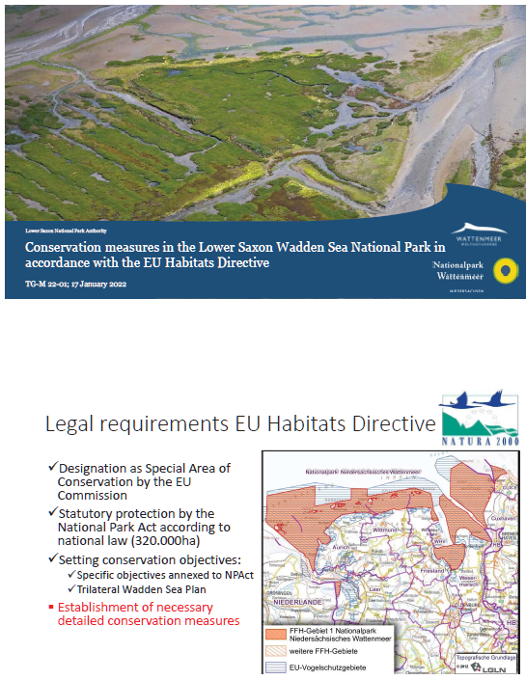

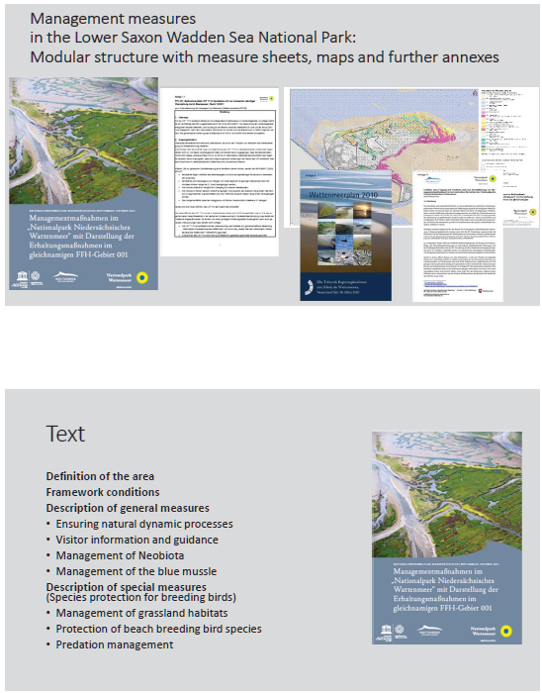
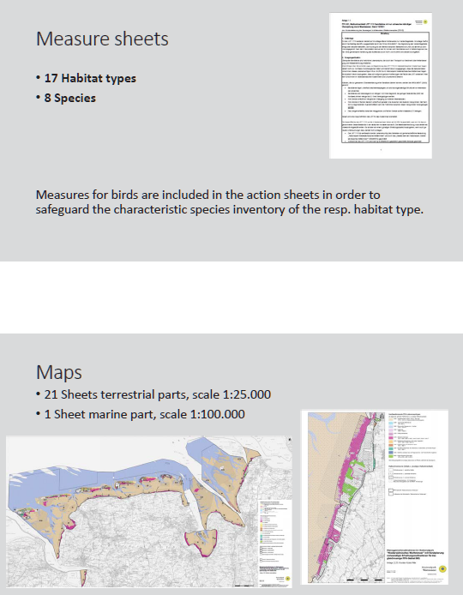
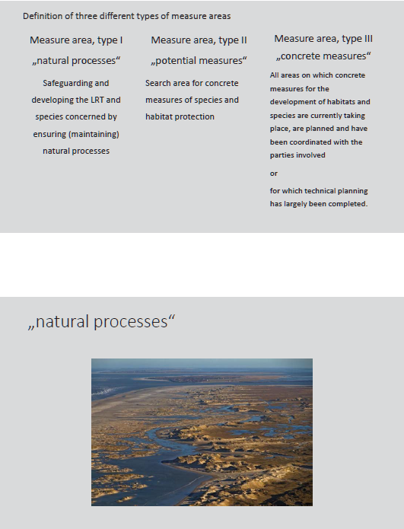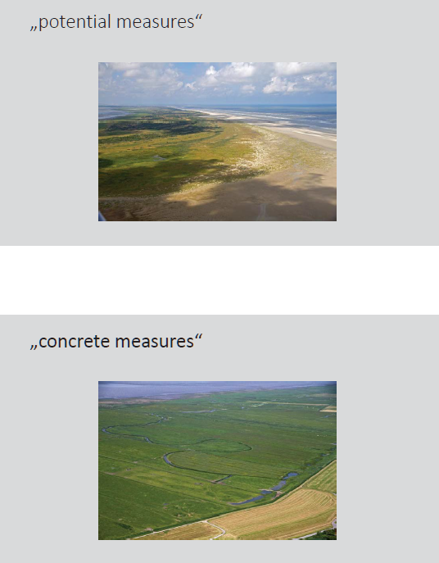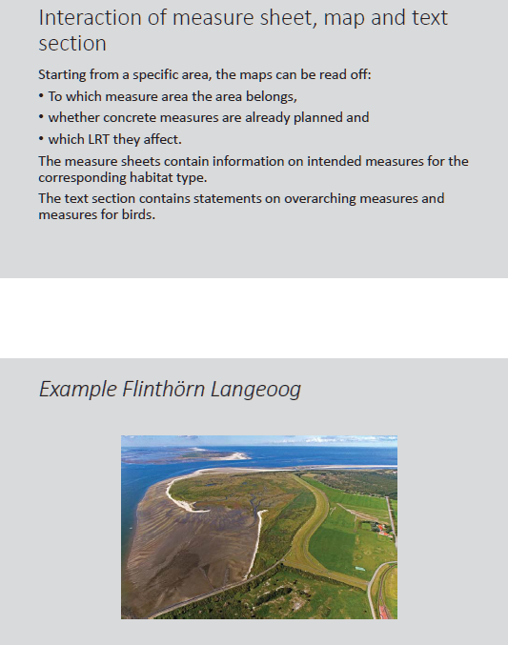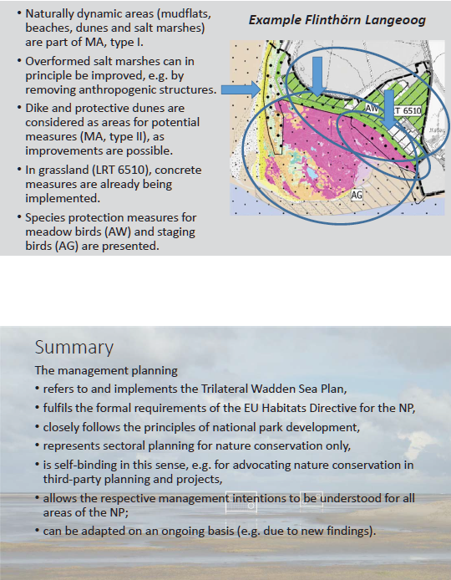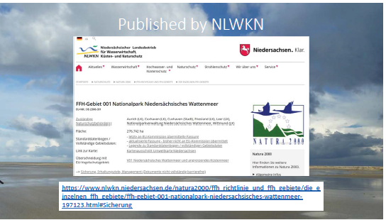

ANNEX 5: Activities TG-M 2022
The following is a list of TG-M related articles of the Leeuwarden Declaration 2018, with input on activities by TG-M during TG-M 22-1.
14. Work intensively on cooperation at the operational management level and secure adequate wardening and management across the whole Wadden Sea Area
To do: A wardening workshop is planned for April 2022. led by the Dutch representation of the Task Group Management (TG-M).
21. Further develop steps for the sustainability of fisheries in the Wadden Sea Area on the trilateral level, in close cooperation with responsible authorities and relevant stakeholders and initiatives (e.g. certification procedures), within the Framework for Sustainable Fisheries, taking into account both the importance of the ecosystem service of providing regional sea food in this respect and the integrity of the World Heritage Site
To do: Completion of Document with status and recommendations for principles of the Framework for Sustainable Fisheries (Annex 3 Tønder Declaration), including analysis how existing legislative framework, regulations, agreements and initiatives support the Framework. Status has been outlined by Schleswig-Holstein and the Netherlands. Danish input to the status is expected for January 2022, Lower Saxony input TBD. After first input to the status, CWSS will draft a first version, based on which TG-M may decide how to proceed for discussion of recommendations/advices for management. Focus is on how to make a difference towards sustainable fisheries; Have status ready for next meeting. HJ to provide Danish input, JB to proceed with LW input. At next tg-m meeting based on the status discuss “recommendations”/advices for management
To do: discuss level playing field (action item 7 of TG-M 21-4) based on document above and qsr, take this up in the next TG-M meeting (TG-M 22-2).
22. Substantially reduce the amount of marine litter in the Wadden Sea by the year 2030
See LD 23
23. Make use of all relevant existing monitoring and action programmes, as well as existing action plans, to gain and exchange adequate additional knowledge on sources and impacts of marine litter on the Wadden Sea ecosystem and stimulate and support appropriate measures
To do: upon contribution of the Task Group Monitoring and Assessment (TG-MA) to recommendations drafted by TG-M, based on WSB 32/5.2/5 TG-M Marine Litter inventory, submit recommendations to WSB. [await feedback from tg-ma, if not possible in near future leave out monitoring part from list of recommendations]
To do? Foster collaboration between all relevant groups in the TWSC, e.g., TG-M, TG-MA, TG-WH, Partnership Hub, Tourism;
LD 29. Instruct the Wadden Sea Board to review and monitor the impacts of renewable energy production and energy transportation on the Wadden Sea ecosystem and to consider measures to avoid or mitigate possible negative impacts by looking for best environmental practices also with the aim of developing, for example, related common principles to evaluate the impact of high-voltage power cables in the Wadden Sea Area in close consultation with the responsible bodies and stakeholders
To be treated by new ad hoc Working Group Cables and Pipelines.
LD 30 Encourage ports and ferry companies working in the Wadden Sea Area to develop codes of conduct to further demonstrate their willingness to work towards environmentally sound standards in accordance with best available technology
LD 33 Encourage the further development and application of environmentally friendly port concepts through the joint organizations of ports, for example by exchange of best practices
No activity by TG-M
LD 31 Request the Wadden Sea Board to consider the different approaches of the three countries in order to identify the most sustainable modes of transport for ensuring nature-friendly site-specific connections to the islands in the future;
No activity by TG-M
32. Encourage the competent national shipping and nature conservation authorities to continue their dialogue in order to achieve an even higher level of safety and cooperation, inter alia by raising the general awareness and information level;
To do: Follow two-step approach on shipping, step 1 under initiative of RWS (action item 2 of TG-M 21-4). Activity by TG-M after progress in step 1: first discussions amongst relevant ministries of the three countries.
LD 34. Note the ongoing discussions in the framework of the IMO on a possible mandatory prewash of cargo tanks having contained paraffins, whereby the prewash residue shall be discharged into a port reception facility
To be taken up in inventory made by ports/PH-WSTandWSF project
No activity by TG-M in 2022. .. IMO decision mid 2021 – seek information on implementation
Overall shipping: TG-M to inform WSF (Frank Ahlhorn) in written way which question we have .. and invite Frank to next TG-M meeting (TG-M 22-2).
Tønder Declaration 23. Agree therefore to cooperate in evaluating the assessments under the Habitats Directive, also with the aim to prepare a common Natura 2000 roof report for the Wadden Sea.
To do: deliver feasibility study by expert at The University of Aarhus. TG-M and the expert will finish the study including main obstacles to successful completion of such task (an interregional N2000 Roof Report). HJ to complete before WSB meeting in April 2022.
Additional Issues to be considered:
In TG-M, additional topics, such as water sports regulations (closed areas, limitations) and air traffic (lowering of min flight height) has been tackled. In addition, use of drones seems to gain importance -leisure as well as for monitoring purposes.
TG-M to decide on completion of collection of shape files for water sports/leisure

ANNEX 6: TG-M support for Ministerial Council Declaration (MCD)
PREAMBLE
- Crucial site for sustainable biodiversity (from talk Peter Shadie, IUCN, how can we harness the power of World Heritage post 2020?).
- Need to have a sound basis for decision-making (management measures required, inform regional/local policies/strategies): have a harmonized, long-term, adequate monitoring in place which will be adapted to current developments/needs

NATURE CONSERVATION AND INTEGRATED ECOSYSTEM MANAGEMENT/SUSTAINABLE DEVELOPMENT
The ministers......
Instruct the Wadden Sea Board to
- Consider a (voluntary?) restriction for fisheries/shipping for certain places or times of the year as e.g., if Eider ducks are present.
- The biodiversity strategy may offer an additional strategic way: if a closure of x% (as resource use/ use free zones) would be requested, the trilateral ambition -being World Heritage- may be higher. EU biodiversity strategy for 2030: Legally protect at least 30% of the EU’s land area and 30% of its seas. Strictly protect at least a third of the EU’s protected areas - representing 10% of the EU land and 10% of EU sea -including all remaining primary and old-growth forests as well as other carbon rich ecosystems, such as peatlands, grasslands, wetlands, mangroves and seagrass meadows.
- Increase knowledge and scientific insight to substantiate the benefit of nature by possible measures, e.g., the importance of the Wadden Sea as spawning ground or nursery area for g fish.
- Exchange best practices on how to make fisheries more nature friendly on trilateral level. Also, an exchange on the consequences for the Wadden Sea, due to the planned increase of wind energy offshore and the necessity for its maintenance and connection to land may be fostered.
- Developing an implementation strategy on how to achieve a level playing field (fisheries) in the three countries (go up from the lowest one) (compare article on level playing field in the Leeuwarden Declaration 2018).
- Exchange best practices regarding [wardening & site-management], management measures (predator management, restoration of habitats, protected areas for species, visitor guidance system...).
- The SIMP can be used for first steps to identify fields of work and the institutions/persons relevant for implementation.
- Renewable energy – consequences for Wadden Sea of the implementation of the ambitious goals of the three Wadden Sea states to accelerate construction of offshore wind farms in their EEZs (and territorial waters), need for common approach regarding cable crossings.
- Interconnectedness between coastal waters, the hinterland and the offshore zone for migrating species such as birds, fish, marine mammals – different functions in the life cycles or in the course of the year. Migratory routes (but also resident species). Keywords: N2000/habitat network, blue green infrastructure.
- Shipping safety measures – consider input from regional/local level. Shipping in Wadden Sea itself, such as recreational (as a supplement to IMO measures in place).
- Identify adequate measures/ information tools to communicate trilaterally what is/will be done regarding the topic of marine litter (fishing gear, microplastic, single use plastics) on a national level (MSFD, round tables Marine Litter etc) and international level (OSPAR).
- Strengthen interdisciplinary approaches both in research as in management, as natural and cultural heritage are inseparable parts of the Wadden Sea’s OUV (Karin Lochte, ISWSS), while noting that Wadden Sea is natural World Heritage property.
- Keep in mind (but not propose) and refer to SIMP: Analyzation of legislation in the three countries (if adequate) to protect the OUV of the Wadden Sea. In this context, it may also interesting to look at rules and frame works for management measures in the three countries and try to harmonize them. (Karin Lochte ISWSS).
- Note: Sensitivity maps and their relevance, e.g., for fisheries, protection of fish and cable laying (the latter for ad hoc Working Group Cables and Pipelines).

