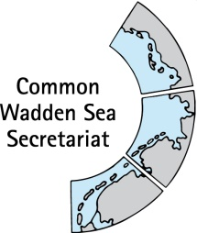
MEETING DOCUMENT
Task Group Management (TG-M 20-2)
TG-M 20 Topical Meeting: Sustainable Fisheries
17 July 2020
Online meeting

Agenda Item: Sustainable fisheries
Subject: Framework Sustainable Fisheries: Status and recommendations
Document No.: TG-M 20/Topical Meeting: Sustainable Fisheries/2
Date: 02 July 2020
Submitted by: CWSS

At the Wadden Sea Board (WSB) meeting 31 held on 18 June 2020, the Board endorsed a proposal on how to handle the issue of sustainable fisheries as submitted by the Task Group Management (TG-M). This working approach includes an update of an inventory on sustainable fishery in the Wadden Sea Conservation Area, as well as an overview of the current situation/practices of sustainable fisheries based on the “Framework for sustainable fisheries” (Annex 3 Tønder Declaration).
1) Update and completion of fishery inventory
2) Status and recommendations for principles of a Framework for Sustainable Fisheries (Annex 3 Tønder Declaration)
Product 1: Inventory on fishery activities in the Wadden Sea Conservation Area.
Product 2: Document with status and recommendations for principles of the Framework for Sustainable Fisheries (Annex 3 Tønder Declaration), including analysis how existing legislative framework, regulations, agreements and initiatives support the Framework for Sustainable Fisheries.
Both products will also serve as basis for the key topic ‘sustainable fisheries’ in the single integrated management plan (SIMP)
This document contains a suggestion for structure and purpose of product 2, as well as a first draft for status and recommendations of the Framework Sustainable Fisheries as updated and commented by Schleswig-Holstein for TG-M 20-2. This document also contains room for TG-M suggestions/notes on content, responsibilities and timeline (in yellow).
Proposal: Agree on the structure and purpose
Add to the status of the principles and agree on next steps including assignment of tasks and timeline

Towards product 2: Status and recommendations for principles of the Framework for Sustainable Fisheries

Structure of the document
- Summary
- Introduction
- Principles of the Framework Sustainable Fisheries: Status and recommendations (per principle).
- Discussion and conclusions

Purpose
Stand-alone document to:
- Assess status (six years after Tonder) and give recommendations for each of the principles of the Framework
- Use for the single integrated management plan (SIMP), in particular for referential structure for key topic Fisheries: “Strategies and actions for management” and “Gaps”. In addition, the use of the Framework for OUV
- Next steps to be discussed, e.g., Best practices? Policy brief?

Product 2: Six (Seven?) years after Tønder: Status and recommendations for principles of the Framework Sustainable Fisheries in the Wadden Sea

Summary
To be added when 2 – 4 are close to final. Who: TBD

Introduction
To be added. Who: TBD

Principles of the Framework Sustainable Fisheries: Status and recommendations
See next page

1. Appropriate assessment or equivalent impact assessments Within the framework of relevant EU legislation (e.g. the Habitats Directive, the Bird Directive, the Marine Strategy Framework Directive and the Water Framework Directive), assessments should be applied to all fisheries sectors in the Wadden Sea. This should be done as an exchange of knowledge and experiences trilaterally in relation to impact assessments, with the aim to secure comparable methods and standards between the trilateral countries. These assessments must be based upon nature conservation objectives, specified to the extent possible, scientifically robust, trilaterally comparative and transparent. The use of regular impact assessments by all Wadden Sea regions would also level the playing field and may facilitate the dialogue between the fishery managers, the industry and environmental NGOs at a trilateral level

Status: Fishery is regulated by EU and national legislation, the latter comprises fishery law as well as nature protection law in the three states.
Status dialogue? Note: Dialogue on brown shrimp fishery by Joint Working Group (NGOs, fishery) on-going in course of MSC surveillance.
What (else) should the status for this principle address?
Which impact assessments are applied to all fisheries sectors in the Wadden Sea? Are these based upon nature conservation objectives, specified to the extent possible, scientifically robust, trilaterally comparative and transparent? Are there comparable methods and standards?
What are specific nature conservation objectives
Who should be addressed:
For legal framework and common ground see inventory (product 1)
When should this information be added:

Recommendation for management action for the upcoming five (?) years:
Identification of gaps and recommendation will be based on the status.
Who should be addressed:
When should this information be added:

2. Fishing gear/best practice The application of appropriate fishing gear and best practices is another essential element in operationalizing sustainable fisheries, in particular with the aim of reducing impacts on the bottom and reducing bycatch. Best practice is understood to be a combination of fishing techniques and fishing effort, minimising impacts. A detailed analysis of fishing gear (application, site specific impact) may be part of the dialogue with the stakeholders. The fishing industry should be encouraged to develop more sustainable techniques and practices.

Status shrimps: Alternative techniques with potentially less impact to the ecosystem are under development, as well as corresponding national management and protection regimes (Baer et al. 2017). In the course of MSC certification, the mesh size is intended to increase from originally 20 mm to 24 mm according to the Brown Shrimp Management Plan. The CRANIMPACT project on impacts of shrimp fisheries on habitats and communities in the coastal seas of the Federal States of Schleswig-Holstein, Hamburg and Lower Saxony is on-going (2018 – 2022) (Thünen Institute 2020).
Status blue mussels (and other shellfish): Spat collection on site and import? Spat quota per farmer? Harvesting techniques, including handling and processing (on the vessel?)? Environmental effects on bottom?
Best practice on 1) Seed dredging effects on bottom and benthic communities. 2) Deposition of organic matter below the rearing structures – deposits can result in an increase of several centimetres of sediment a year, inducing changes in sediment composition and benthic community structures. 3) Carrying capacity issues and food competition when overstocking occurs. 4) Invasive patterns when introduced into a new ecosystem (http://www.fao.org/fishery/culturedspecies/Mytilus_edulis/en) (Items 1 – 4 by Food and Agriculture Organisation (FAO) )

What (else) should the status for this principle address?
Who should be addressed:
When should this information be added:

Recommendation for management action for the upcoming five (?) years:
Identification of gaps and recommendation will be based on the status.
Who should be addressed:
When should this information be added:

3. Closed areas Closed areas are a management option for sustainable fisheries in the Wadden Sea Conservation Area, in particular to allow natural processes to proceed in an undisturbed way, to achieve the conservation objectives and biodiversity and in cases where there is insufficient knowledge about impacts. Sufficiently large closed areas can also serve as reference and recovery areas. The designation of such areas is in the responsibility of the national state, taking into account the relevant EU regulations.

Status: Several areas are closed for shrimp and mussel fishing activities, with different extent over the three countries. Denmark has banned shrimp and mussel fishery entirely (Figure 1) (Baer et al. 2017). Closed areas were, however, not completely avoided by brown shrimp fishery (German vessels, 2007 – 2013) (Kuechly et al. 2016).
“The effects of mussel fishery are limited by the permanent closure of considerable areas and the reservation of sufficient amounts of mussels for birds. In addition, the management of fishery on mussels should not be in conflict with protecting and enhancing the growth of natural mussel beds and Zostera fields.” Wadden Sea Plan 2010: 4.23 (identical to 9.6)
What (else) should the status for this principle address?
Are considerable areas permanently closed? Are there sufficient amounts of mussels reserved for birds?
Are there temporarily closed areas?
Are closed areas respected?
Are there significantly large recovery and reference areas?
Who should be addressed:
When should this information be added:

Recommendation for management action for the upcoming five (?) years:
Identification of gaps and recommendation will be based on the status.
Who should be addressed:
When should this information be added:
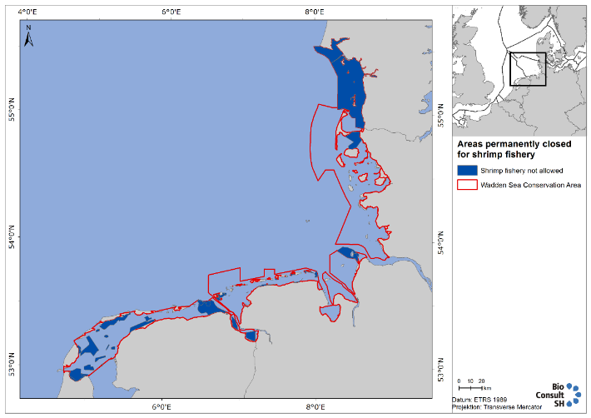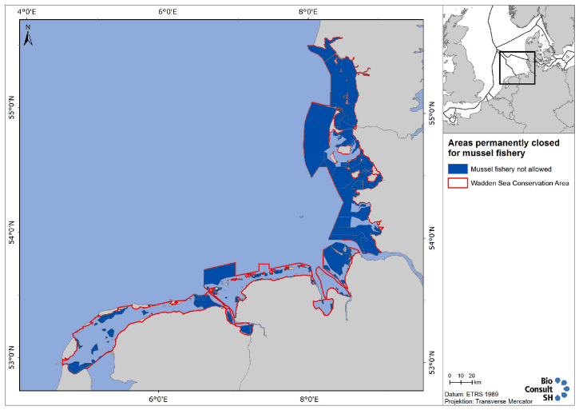
Figure 1: Maps showing Wadden Sea areas closed year-round (dark blue) in Wadden Sea Conservation Area (red line): left: shrimp fishery; right mussel fishery. The map on mussel fishery includes future closed areas in Schleswig-Holstein when the updated management plan comes into effect (Source: figures 4 and 9 of QSR thematic report on fishery).

4. Monitoring/control/black box This includes monitoring of fishing activities and the status of fished and closed areas. The fisheries sector is co-responsible for monitoring of fishing activities. Black boxes, or equivalent systems (e.g. VMS), are an important precondition for co-management, including nature protection.

Status: TBD Data from Automatic Identification System (AIS) and the Vessel Monitoring System (VMS) messages show low to very high fishing intensity in the Wadden Sea Cooperation Area (JRC, compare Figure 2).
Fishing activity of members (MSC) are monitored through VMS mapping every year to monitor the risk of any expansion into sensitive habitats (vessel Monitoring System (VMS) plots for brown shrimp fishery are provided for the Netherlands, Germany and Denmark within the MSC certification process, compare figure 8 in Addison et al 2019).
What (else) should the status for this principle address?
How are fishing activities and effort monitored? Are closed areas respected?
Are there spatio-temporal trends in activities and efforts?
Who should be addressed:
When should this information be added:

Recommendation for management action for the upcoming five (?) years:
Identification of gaps and recommendation will be based on the status.
Who should be addressed:
When should this information be added:

5. Stock assessment Regular stock assessments must be carried out to serve as a basis for stock management as clarified in the EU Common Fisheries Policy and other relevant EU legislation. This is an essential element for sustainable fisheries. Fishing impact should be such that stable food webs are restored and maintained, supporting natural populations of predators.

Status shrimps: Until 2016 there were no annual stock assessments for brown shrimps in the North Sea, yet there are signs of growth overfishing for this species (Tulp et al 2016). For this short-lived species, a conventional age-based stock assessment is not possible. “ICES advised that the development of a harvest control rule (HCR) based on a comparison of the most recent commercial landings per unit effort (LPUE) data with pre-defined trigger levels (based on previous LPUE data) was the most appropriate approach for this short-lived species. ICES also advised that Crangon should be taken into account within the framework of ICES advice regarding North Sea mixed fisheries because of the significant bycatch of other species in the small-meshed net Crangon fisheries, and in relation to multispecies interactions because future recovery of gadoid populations could have an impact on shrimp population dynamics” (Addison et al 2019).
It is unclear, if fishing pressure would reduce shrimp availability to predators (Tulp et al 2016).
Status mussel:
Status fish:

What (else) should the status for this principle address?
Who should be addressed:
Status fish: ad hoc WG-SWIMWAY
When should this information be added:

Recommendation for management action for the upcoming five (?) years:
Identification of gaps and recommendation will be based on the status.
Who should be addressed:
When should this information be added:

6. Appropriate knowledge<>responsibility of all parties involved In the process of operationalizing sustainable fisheries, use must be made of best available knowledge. There is a responsibility of all parties involved in supporting knowledge about the status of the ecosystem.

Status
What (else) should the status for this principle address?
Who should be addressed:
When should this information be added:

Recommendation for management action for the upcoming five (?) years:
Identification of gaps and recommendation will be based on the status.
Who should be addressed:
When should this information be added:

7. Pilot studies (learning by doing) Transition towards sustainable fisheries also implies that there must be ample possibilities for testing new methods and practices. Knowledge gained in pilots should be spread among all parties involved

Status Several projects have been and are being conducted. Amongst them is CRANNET (Thünen Institute 2020), in which improvement of cod end selectivity (result: cod ends with T0 or T90 meshes and a mesh size of 26 mm or square mesh cod ends (T45) with a mesh size of 24 mm were identified to increase the sustainability of brown shrimp fisheries in terms of ecological and economic aspects) and reduction of by-catches in brown shrimp fishery were in the focus from 2012 – 2015.
What (else) should the status for this principle address?
Who should be addressed:
When should this information be added:

Recommendation for management action for the upcoming five (?) years:
Identification of gaps and recommendation will be based on the status.
Who should be addressed:
When should this information be added:

Study on fishing gear for shrimp fishery

Discussion and conclusions
To be added. Who: TBD

