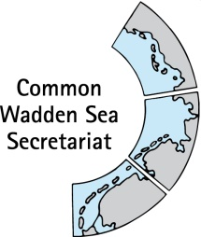
WORKING DOCUMENT
Task Group Management (TG-M)
TG-M 20 Topical Meeting: Sustainable Fisheries
17 July 2020
Online meeting

Agenda Item: Sustainable fisheries
Subject: Inventory on fishery activities in the Wadden Sea Conservation Area
Document No.: TG-M 20/ Topical Meeting: Sustainable Fisheries/1
Date: 02 July 2020
Submitted by: CWSS

At the Wadden Sea Board (WSB) meeting 31 held on 18 June 2020, the Board endorsed a proposal on how to handle the issue of sustainable fisheries as submitted by the Task Group Management (TG-M).
1) Update and completion of fishery inventory
2) Status and recommendations for principles of a Framework for Sustainable Fisheries (Annex 3 Tønder Declaration).
Product 1: Inventory on fishery activities in the Wadden Sea Conservation Area.
Product 2: Document with status and recommendations for principles of the Framework for Sustainable Fisheries (Annex 3 Tønder Declaration), including analysis how existing legislative framework, regulations, agreements and initiatives support the Framework for Sustainable Fisheries.
Both products will also serve as basis for the key topic ‘sustainable fisheries’ in the single integrated management plan (SIMP)
This document contains a draft inventory on fisheries in the Wadden Sea Conservation Area as updated and commented by TG-M for TG-M 20-2. The document further contains a trilateral common ground and draft legal framework for sustainable fisheries in the Wadden Sea Cooperation Area. This draft may serve as chapter for the SIMP and background information presented in an online microsite. It may also serve as source of information for assessment of the current status and recommendation for each of the principles of the Framework for Sustainable Fisheries.

Proposal: Agree on structure and next steps.

Towards product 1: Inventory on fishery activities in the Wadden Sea Conservation Area

Structure of the document
- Draft fisheries inventory for the Wadden Sea Cooperation Area
- Draft common ground for Sustainable Fisheries in the Wadden Sea Cooperation Area
- Draft legal framework for Sustainable Fisheries in the Wadden Sea

Purpose

Draft chapter for the SIMP key topic fisheries and background information presented in an online microsite; in particular for referential structure for key topic Fisheries: “Inventory” and “Common ground”.

Source of information for assessment of the current status and recommendation for each of the principles of the Framework for Sustainable Fisheries.

Product 1: Sustainable fisheries in the Wadden Sea Conservation Area

Draft fisheries inventory for the Wadden Sea Cooperation Area
Commercial fisheries in and adjacent to the Wadden Sea concentrate on brown shrimps (Crangon crangon) and mussels (predominantly blue mussels Mytilus edulis). Small-scale fisheries include cockles (Cerastoderma edule)(Baer et al., 2017). A review in 2013 pointed towards possible importance of finfish fisheries (bass and mullet) (Sieben et al., 2013). Also, non-commercial fishing takes place in the Wadden Sea (Table 3).

The brown shrimp population spreads throughout the entire North Sea region; the population is fished mainly in territorial waters (12 nm, where EU member states have exclusive management rights (art. 5 Regulation (EU) 1380/2013)). Largest fractions are landed by Denmark, Germany and the Netherlands (Figure 1). Total annual landings in the North Sea increased since 1960 and reached more than 38,000 t, but decreased from 2015 to now 22,ooo t (ICES, 2019) Figure 1). Brown shrimps in the North Sea were targeted by a total of 522 vessels in 2015 (ICES, 2018: uncertainty due to difficulties in obtaining information on numbers of, e.g., smaller ships).

In 2017, shrimp fishery in the North Sea has been certified by the Marine Stewardship Council (MSC) Sustainable Fisheries (Addison et al., 2017) which also implies new developments and information for the Wadden Sea Conservation Area, including a Brown Shrimp Management Plan. The Unit of Certification (UoC) for the MSC covers a total of 422 Danish (7%), German (45%) and Dutch vessels (47%) (with a recent inclusion of Belgian vessels (1%)) for the North Sea (Addison et al., 2019). These are catching brown shrimp in the North Sea by use of lightweight beam trawls, largely within territorial waters. Recently, the first MSC surveillance report has been submitted (Addison et al., 2019), which includes an updated version of the Brown Shrimp Management Plan. Fishery within the UoC is limited by a set of general rules for capacity, effort and gear (Addison et al., 2019).
Separate view on Wadden Sea? About 300 licenses for shrimp fishing vessels were issued in Denmark, Germany and the Netherlands for the Wadden Sea, which account for more than half of the North Sea fleet for Brown shrimps (comparable to vessel numbers above?). Landings in the Wadden Sea Cooperation Area and World Heritage Area?

Include comparison of the most recent commercial landings per unit effort (LPUE) data?
Include trends?

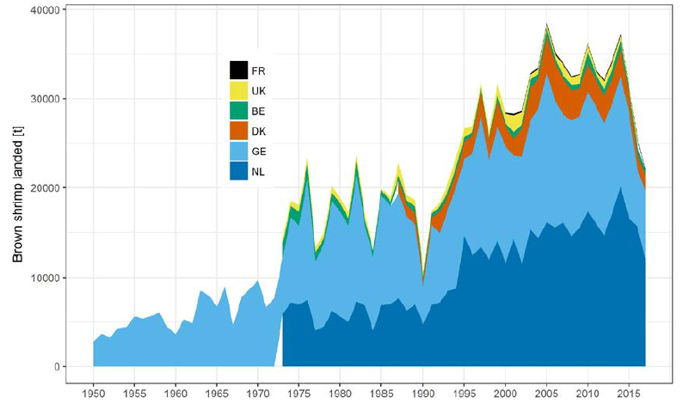
Figure 1: Total landings of brown shrimp from the North Sea [tons] by country. (Data for UK 2017 is lacking.) Source. ICES, 2019 [FUTURE: USE WADDEN SEA VS NORTH SEA REGION SHRIMP LANDING DATA OR EFFORT DATA?]
Blue mussels are cultivated and harvested in German and Dutch coastal zones, while the Danish Wadden Sea Area is permanently closed for such activities.
Seed mussels of 1-4cm length are collected from natural mussel beds, usually by means of a mussel dredge, but also by artificial seed collectors (Sieben et al., 2013). In the Netherlands, additional spat is imported from UK and Ireland; permissions to import from other parts of the North Sea exist for Schleswig-Holstein, though import was stopped by court rule in December 2011, but these are dormant (Sieben et al., 2013). Except for the Netherlands, there is no quota for seed mussels.
These seed mussels are grown in bottom-culture lots. A total of 102 licenses for mussel fishing vessels were in place in 2019. Licenses for culture lots? In 2019, the total area for culture lots in use was 5,275 ha (of approx. overall 10,000 ha culture area?). In the Wadden Sea Conservation Area an annual average of 38,400 tons (wet weight?) was harvested between 2015 – 2019 (in NL: 2009 – 2019); 53 % were landed in the Netherlands on 66 % of the used culture area, while 47 % were landed in Germany in 34 % of the used culture area (Figure 1, Table 1 TBD).

Include trends (change of landings (t) or area, overall/area, in use (ha))?

Figure 2: Left: Average annual landings of blue mussels (Mytilus edulis) in Schleswig Holstein (SH), Lower Saxony (LS) and the Netherlands (NL) in the Wadden Sea Cooperation Area (t, %);
Right: mussel culture area in use (ha, %).
The Danish Wadden Sea Area is permanently closed for mussel culture.
Cockle fishery is allowed only in the Netherlands, exclusively by hand-picking and with a maximum of 31 licenses for manual cockle fishery.

There are closed areas for both shrimp and mussel fishery.
- Show on map? shape files?

Tables 1- 4. Current status of these tables are submitted in a separate excel file.

Draft common ground for Sustainable Fisheries in the Wadden Sea Cooperation Area
Fishing activities in the Wadden Sea effect the ecosystem beyond target species.

Trilateral principles for sustainable fisheries in the Wadden Sea Conservation Area (Annex 1) are laid down in the “Framework for sustainable fisheries” (Annex 3 Tønder Declaration(CWSS, 2014)).
In the Wadden Sea Plan 2010 (CWSS, 2010) it is stated that fishery may affect the natural environment of the Wadden Sea with most important fisheries within the Nature Conservation Area being for blue mussel and shrimp.
Trilateral agreements on policy and management for sustainable fisheries in the Wadden Sea Plan are described under the Targets Tidal Areas (4), Birds (9) and Fish (11):
4.22 (identical to 9.5) Cockle fishery is not allowed in the Wadden Sea Area, with the exception of mechanical fisheries in some small areas along the Esbjerg shipping lane and in the Ho Bay, and in Niedersachsen outside of the conservation area (but will not be carried out at present), as well as non-mechanical cockle fishing in The Netherlands.
4.23 (identical to 9.6) The effects of mussel fishery are limited by the permanent closure of considerable areas and the reservation of sufficient amounts of mussels for birds. In addition, the management of fishery on mussels should not be in conflict with protecting and enhancing the growth of natural mussel beds and Zostera fields.
4.24 (identical to 9.7) Mussel fishery will, in principle, be limited to designated parts of the subtidal area. Based on national management plans, fishery on the tidal flats and parts of the sub-littoral may be granted. The fishery sector will, in close cooperation with competent authorities, improve existing practices in such a way that impacts of mussel fishery in general and seed mussel fishery in particular, will be minimised.
4.25 The current area of mussel culture lots will not be enlarged.
4.26 The existing permit for oyster culture in Schleswig-Holstein will remain in force. New permits will not be granted.
4.27 (identical to 11.3) In order to reduce bycatch and to reduce impact on the sea floor, trilateral policy principles for a sustainable shrimp fishery will be developed in close cooperation with the fisheries sector.
These agreements towards sustainable activities in the Wadden Sea are backed up by national management plans and policies in the three countries (Table 5).

Draft legal framework for Sustainable Fisheries in the Wadden Sea
Fisheries taking place in the area between the 12 and 200 nm in Denmark, Germany and the Netherlands are subject to the principles and practices Common Fisheries Policy (CFP) of the EU. In the Wadden Sea, this is the case only for the shrimp fisheries that come to pass the 12 nm limit off the coast. Among the main elements of the CFP is the calculation and implementation of Total Allowable Catches (TAC) for the different fisheries. For brown shrimp, no TAC system in the North Sea is in place (Steenbergen et al., 2017), nor effort restrictions or special measures (PRW, in progress). Another element of the policy that has an effect on the shrimp fisheries is the EU Regulation No 850/98 that defines the technical measures that are obligatory in European fisheries. Brown shrimp fishers must use nets with a mesh size not smaller than 16mm and selective gears consisting of sieve nets that conduct by-catch to an escape hole in the body of the trawl (Revill and Holst, 2004). Through the MSC certification (in 2017), brown shrimp fishers voluntarily agreed to improve the efficiency and selectivity to reduce by-catch, to avoid fishing in sensitive habitats and to manage the shrimp fishery in case populations decrease below a critical level, and to accept no-take zones given scientific research recommends this (PRW, in progress, see MSC brown shrimp management plan).
Mussel and cockle fisheries in the Wadden Sea occur within the 12 nm. In this area, the legal basis for management is responsibility of each of the three countries. Since each of the three countries have also designated Natura 2000 sites in the Wadden Sea, the respective EU Habitats and Birds Directives require that the Member States achieve favourable conservation status of defined habitats and species.
In Denmark and Germany, the Marine Strategy Framework Directive (MSFD) is applied to the Wadden Sea providing an overarching framework for sustainable fisheries (and sustainable ecosystems) in marine coastal areas such as the Wadden Sea. It requires the development and implementation of strategies to:
- protect and preserve the marine environment, prevent its deterioration or, where practicable, restore marine ecosystems in areas where they have been adversely affected; and
- prevent and reduce inputs in the marine environment, with a view to phasing out pollution, so as to ensure that there are no significant impacts on, or risks to, marine biodiversity, marine ecosystems, human health or legitimate uses of the sea.
The MSFD requires the application of an ecosystem-based approach to the management of human activities and the integration of environmental concerns into the different policies, agreements and legislative measures which have an impact on the marine environment (CWSS, 2010).
The interpretation and implementation of the EU Directives is different among the three countries. The legal framework at the national level and its application also differs among the countries (Table 5).

Table 4. Possible layout of overview of laws and main policy documents for fisheries (and other non-water laws which influence implementation of fisheries) which back up trilateral agreements in Denmark, in the three German Federal States and the Netherlands.
Wadden Sea World Heritage property in… | Shrimp fishery | Blue mussel fishery | Cockle | Other
All | The EU Common Fisheries Policy (CFP) applies to the fisheries occurring between the 12 and 200 nm.  Plaice Box (EU legal restriction, 1986 (Regulations (EEC) 3094/86 and 55/87)
the Netherlands | Habitats and Birds Directives  Agreement between the fishing industry NGOs and the Dutch government (2011) as part of the “VIBEG” agreement to fisheries regulation scheme in accordance with Natura 2000.  VISWAD aims at the transition to a more sustainable way of shrimp fishing, the accreditation with the certificate of the Marine Stewardship Council (MSC) is one of the results of the more sustainable way of fishing. | Habitats and Birds Directives  Fisheries Act 1963  Order on Sea and Coastal Fisheries  Uitvoeringsregeling visserij (Fisheries Implementing Agreement)  2005-2020 Policy Decision on Shellfish Fishery  Nature Conservation Act 1998  Reglement Mosselvisserij and Reglement afdoening overtredingen (Mussel Fisheries Regulations and Regulations for the settlement of violations)  Mosselconvenant is an agreement on the transition of mussel seed fishery to spat collectors. | Nature Conservation Act  Agreement between the cockle industry, conservation NGOs and the Dutch government (2011) acts as a policy rule in the Nature Protection legislation and Fisheries legislations | Fisheries Act (Visserijwet 1963) with a follow-up in the Sea and Coast Fisheries Act (Reglement zee- en kustvisserij 1977, valid from 01-01-2015 up to date) and translated into a regulation on Fish (Uitvoeringsregeling Visserij). Fish species can be included in the Fisheries Act with a minimum size and / or closed seasons (PRW, in progress).
Germany
Lower Saxony | Habitats and Birds Directives  Marine Strategy Framework Directive  National Park Act (zonation…) | Habitats and Birds Directives  Marine Strategy Framework Directive  Niedersachsen Fishery Ordinance of 1992+ (is this the same as fisheries law?)  National Park Act (zonation…)  Seed import not explicitly regulated by National Park Law. The seed-mussel fishery is allowed in the frame of a management plan (actual plan valid 2019-2023), implemented in the National Park law. This plan is a central part of the regulations of the seed mussel fishery. The plan contains:  -29 sites out of a total of 102 intertidal sites are closed for seed mussel fishery (12 closed by law, 17 closed by management plan)  - Approval for seed fishery on unstable mussel beds not granted if a minimum area of 1.000ha and a biomass of 10.000 t is undercut by more than 10%.  -The fishery for consumption mussels on natural mussel beds in the intertidal areas is not allowed.  - import of seed mussels from areas outside specified geographic limitations is not allowed
Hamburg | Habitats and Birds Directives  Marine Strategy Framework Directive  National Park Act (shrimp fishing for human consumption in three tidal inlets within the core zone, 5% of the HH area) | -
Schleswig-Holstein | Habitats and Birds Directives, Marine Strategy Framework Directive  National Park Act (shrimp fishery allowed in zone 1 and 2, prohibited in zone 0, between the islands of Sylt and Föhr) | Habitats and Birds Directives, Marine Strategy Framework Directive  SH Fisheries Law applied through SH mussel fishing programme (current 2017-2031)  National Park Act only permits fishing according to the programme  Seed import stopped by S-H Higher Administrative Court (Oberverwaltungsgericht) due to risk of introducing non-native and because National Park Law had not been taken into consideration in granting the import licenses | National Park Act prohibits cockle fishing as well as razor clam | Surf clam fishing is no more permitted since 2017, but has in fact not been carried out since 1997 (PRW, in progress).
Denmark | Statutory order on protection and wild-life sanctuary in The Wadden Sea (Bekendtgørelse om fredning og vildtreservat i Vadehavet)  Due to conservation concerns, the entire inner Danish Wadden Sea area was closed to fishing in 1977 and the regulation is still in force.  Specific regulations for fishery in the Danish part of the Wadden Sea has been laid down in a regulatory announcement: “Specific rules of fishery and conservation areas in the Wadden Sea and in certain streams in South Jutland” | Statutory order on protection and wild-life sanctuary in The Wadden Sea (Bekendtgørelse om fredning og vildtreservat i Vadehavet)  National Fisheries Act (Fiskeriloven)- statutory order concerning the formal regulations in connection with licensing for the fishery of blue mussels | Statutory order on protection and wild-life sanctuary in The Wadden Sea (Bekendtgørelse om fredning og vildtreservat i Vadehavet) | National Fisheries Act (Fiskeriloven)- Statutory order on particular regulations for fishery and conservation Zones in the Wadden Sea and certain South Western rivers and streams ( Bekendtgørelse om særlige fiskeriregler og fredningsbælter i Vadehavet og i visse sydjyske vandløb) prohibits fishing with rod and string in the streams that are connected to the Wadden Sea in parts of the year. Furthermore, an area of 500 m from several creeks and streams are protected. It also puts restrictions on what types of fishing gears are allowed in the Wadden Sea. Restrictions on fisheries is very relevant for the state of the fish in the Wadden Sea (PRW, in progress).
*In the Netherlands, the MSFD is not applied to the Wadden Sea.
+ regulated by State Fisheries Administration which also applies the management plan (Bewirtschaftungsplan) of the National Park Law.

References
Addison, J., Gaudian, G., Knapman, P., 2019. North Sea Brown Shrimp 1 st Surveillance Report 1–81.
Addison, J., Gaudian, G., Knapman, P., 2017. MSC SUSTAINABLE FISHERIES CERTIFICATION North Sea Brown Shrimp Public Certification Report.
Baer, J., Smaal, A., van der Reijden, K., Nehls, G., 2017. Fisheries, in: Klöpper, S., Baptist, M., Bostelmann, A., Busch, J.A., Buschbaum, C., Gutow, L., Janssen, G., Jensen, K., Jørgensen, H.P., de Jong, F., Lüerßen, G., Schwarzer, K., Strempel, R., Thieltges, D. (Eds.), Wadden Sea Quality Status Report 2017. Common Wadden Sea Secretariat, Wilhelmshaven, Germany.
CWSS, 2014. Tønder Declaration. Ministerial Council Declaration of the 12th Trilateral Governmental Conference on the Protection of the Wadden Sea.
CWSS, 2010. Wadden Sea Plan 2010. Eleventh Trilateral Governmental Conference on the Protection of the Wadden Sea 104.
ICES, 2019. Report of the Working Group on Crangon Fisheries and Life History (WGCRAN). Copenhagen, Denmark.
Sieben, C., Gascoigne, J., Nehls, G., Ramirez-Monsalve, P., Raakjar, J., 2013. Sustainable fisheries in the Trilateral Wadden Sea - Final Report.
Steenbergen, J., Trapman, B.K., Steins, N.A., Poos, J.J., 2017. The commons tragedy in the North Sea brown shrimp fishery: How horizontal institutional interactions inhibit a self-governance structure. ICES J. Mar. Sci. 74, 2004–2011. https://doi.org/10.1093/icesjms/fsx053
Revill and Holst, 2004 in Steenbergen, et al., 2017
(Venema, 2001).

ANNEX 1: Map of Wadden Sea Conservation Area and World Heritage property
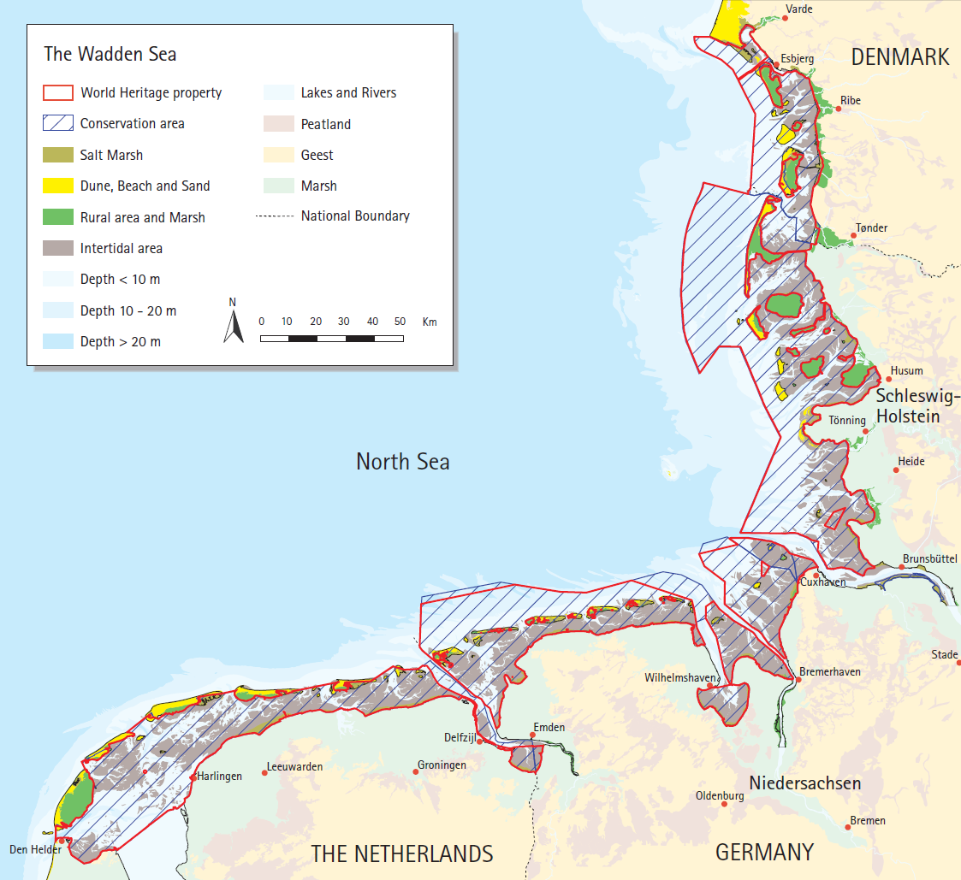
Figure: Wadden Sea Cooperation Area and Wadden Sea World Heritage Area.

in force since 1983: provide a legal framework for the “… rational and responsible exploitation of the living marine resources on a sustainable basis, in appropriate economic and social conditions for the sector taking account of its implications for the marine ecosystem and of the needs of both producers and consumers.” (Venema, 2001).
Brown shrimp fishers must use at least 16mm mesh size and selective gears. These include sieve nets that direct unwanted by-catch to an escape hole in the body of the trawl (Revill and Holst, 2004 in Steenbergen, et al., 2017).

