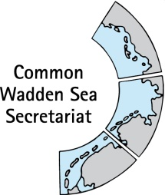
MEETING DOCUMENT
Task Group Management (TG-M 20-2)
14 May 2020
Virtual meeting

Agenda Item: 7. Sustainable fisheries
Subject: Blue Manifesto
Document No.: TG-M 20-2/7.2
Date: 6 May 20
Submitted by: Henrik Jørgensen

At the Wadden Sea Board (WSB) meeting 30 held on 21 November 2019 in Wilhelmshaven, Germany, the Board instructed TG-M to come forward with a proposal how to handle the issue of sustainable fisheries.
More than 100 environmental organisations, led by BirdLife Europe, ClientEarth, Oceana, Seas At Risk, Surfrider Foundation Europe and WWF have launched the “Blue Manifesto”. The rescue plan lays out concrete actions which must be delivered by set dates in order to turn the tide on the ever-degraded and polluted ocean and coastlines.
This document contains a call for change as well as a link to the manifest, which may be used as background document for discussion of a working approach on sustainable fisheries. This document also contains an excerpt of fisheries related items of the manifesto and the vision for healthy seas in 2030.

Proposal: The group is invited to note the information.

Blue Manifesto - The roadmap to healthy ocean in 2030

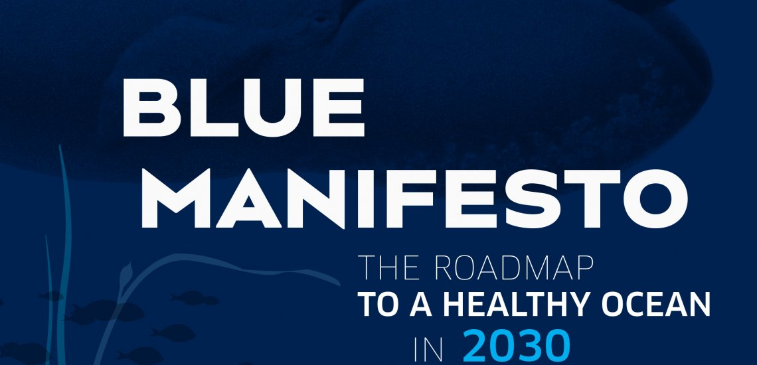
By BirdLife Europe and Central Asia
More than 100 environmental organisations, led by BirdLife Europe, ClientEarth, Oceana, Seas At Risk, Surfrider Foundation Europe and WWF have launched the “Blue Manifesto”. The rescue plan lays out concrete actions which must be delivered by set dates in order to turn the tide on the ever-degraded and polluted ocean and coastlines. To be successful, change is needed on both land and sea. Together, we call for:
• At least 30% of the ocean to be highly or fully protected by 2030
• A shift to low-impact fishing
• Securing a pollution-free ocean
• Planning of human activities that support the restoration of thriving marine ecosystems

Bruna Campos, Senior Marine Policy Officer, BirdLife Europe & Central Asia said: “Saving the oceans means saving both marine species and their habitats. It is about actively restoring our seabeds and halting ongoing destructive fishing. It is incomprehensible how fishing vessels are still allowed to bycatch dolphins, seabirds and sea turtles. We need a transformative change to save our oceans in the next ten years. Nature at sea is in crisis because we lack commitment to change the status quo, and we can no longer afford it. ”

Blue Manifesto – The roadmap to healthy ocean in 2030
Europe And Central Asia Seabirds And Marine
OceanBlue Manifesto

Excerpt of Blue Manifesto – fisheries related items
[..] European countries are legally-bound to put a number of measures in place to achieve clean and healthy seas. They failed to do so before 2020. The following, therefore, still needs to be done as a matter of urgency to address the gap in delivering on commitments: […]
EU countries end overfishing of all harvested stocks under the Common Fisheries Policy. […]
EU countries take measures to end illegal, unreported and unregulated fishing in their waters, by their fleet or by their citizens, under the IUU Regulation, and to fully implement the Deep-Sea Regulation. […]
2020 […]
- EU adopts a Biodiversity Strategy 2030 that protects sensitive marine species and habitats and fish stock recovery areas, eliminates destructive fishing and includes legally binding ocean restoration targets. […]
- EU adopts a Farm to Fork strategy that fully takes into account the ecological and climate impacts of fisheries and aquaculture and addresses responsible consumption and sustainably sourced and traceable seafood. […]
- EU allocates at least 21 billion EUR of the Multiannual Financial Framework for 2021-2027 to protect nature, with at least 50% of the European Maritime Fisheries Fund to restore the marine environment, collect data and control fisheries, and revises the State Aid guidelines for fisheries and aquaculture to prohibit granting of harmful subsidies […]
2021 […]
- EU countries implement effective fisheries management measures to eliminate bycatch of sensitive species. […]
- EU countries adopt ecosystem-based Maritime Spatial Plans which include at least 30% of highly or fully protected MPAs and areas for human activities allocated based on ecosystem sensitivity. […]
2022 […]
- EU establishes trawl-free zones along the whole EU coast to protect the most productive part of our seas and protects all EU Marine Protected Areas from the negative impacts of destructive fishing gears […]
- EU countries set up binding schemes for Extended Producer Responsibility for single-use plastics and fishing gear to maximise eco-design and prevention. […]
- 2023
- Based on the evaluation of the Common Fisheries Policy, EU adopts an Action Plan to ensure its effective implementation resulting in a full transition to low impact EU fisheries
2024, 2025 […]
- EU pushes for the adoption of measures to restrict flags of convenience to close the net on pirate fishers and improve international ocean governance. […]
2027 […]
- EU adopts regulations that ensures that all aquaculture production in EU seas is non-polluting and does not rely on marine-derived feed ingredients […]
2028, 2029 […]
- EU dedicates all of the new European Maritime and Fisheries Fund to activities aimed at restoring and managing the marine environment, collecting data and controlling fisheries. […]
2030 […]
